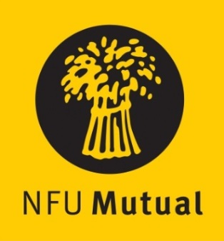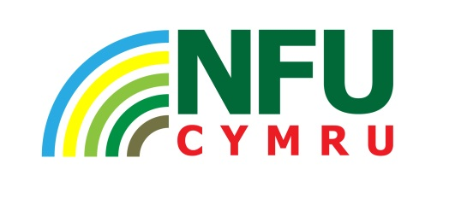

Welsh Dairy Stockperson of the Year Award

Win £500 and a Welsh slate engraved cheese board

NFU Cymru, with sponsorship from NFU Mutual,
announces the launch of a competition to choose
a Welsh Dairy Stockperson of the Year

This Award aims to find the best dairy stockperson working within the agricultural industry in Wales. This competition rewards dedication and commitment and recognises the role a good stockperson can make to the Welsh dairy industry.

Criteria includes:
- Details of the dairy stock you manage

- How you started in the industry and how your role has grown
- Your role in the care and management of your dairy stock

Nominations are invited throughout Wales. Dairy farmers are invited to nominate themselves or can be nominated by a friend, relative or organisation.

Closing date for entries is Monday 7th October 2019.

The Award winner will be announced in the main ring at the Welsh Dairy Show on Tuesday, 29th October 2019.

The completed entry from should be returned either by email to clare.williams@nfu.org.uk or by post marked ‘Dairy Stockperson Award’ no later than 4.30pm Monday 7th October, to: NFU Cymru, Agriculture House, Royal Welsh Showground, Builth Wells, LD2 3TU.

