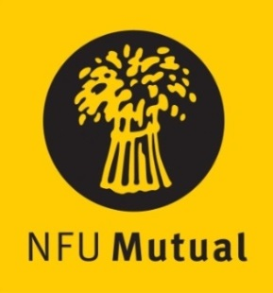

Welsh Dairy Stockperson of the Year Award

ENTRY FORM
Name:
Address:

Tel No. Mobile No.
(Please state in the appropriate sections why the nominee should be considered)
- Details of the dairy stock nominee manages

- How nominee started in the industry and how his/her role has grown

- Nominee’s role in the care and management of dairy stock

[please use a separate sheet if necessary]
__________________________________________________________________________________________
Name and address of person submitting the nomination if different from name above:

Please return the completed entry form either by email to clare.williams@nfu.org.uk or by post marked ‘Dairy Stockperson Award’ no later than 4.30pm on Monday 7th October 2019, to: NFU Cymru, Agriculture House, Royal Welsh Showground, Builth Wells, LD2 3TU.

