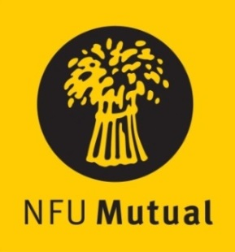

Welsh Livestock Champion of the Year Award

ENTRY FORM
Name:
Address:
Tel No. Mobile No.
(Please state in the appropriate sections why the nominee should be considered)
- How nominee started in the industry and how his/her role has grown, include details of the livestock managed

- Their role in the care and management of livestock

- How they intend developing the business

- Nominee’s vision for the future of the industry

- How nominee incorporates health and safety in their day-to-day activities

[please use a separate sheet if necessary] _________________________________________________________________________________________
Name and address of person submitting the nomination if different from name above:

Please return the completed entry form either by email to clare.williams@nfu.org.uk or by post marked ‘Livestock Champion Award’ no later than 4.30pm on Friday 29th October 2021, to: NFU Cymru, Agriculture House, Royal Welsh Showground, Builth Wells, LD2 3TU.

