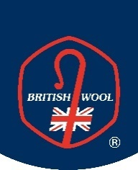
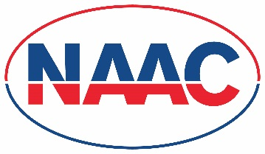
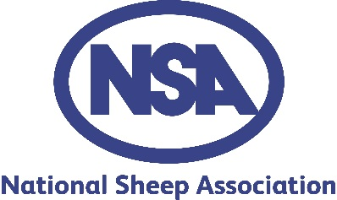
#

Press Release

16 April 2020
New Shearing Checklist for Shearers and Farmers during Covid-19
A new industry checklist has been produced to ensure that shearers, wool handlers and farmers in the UK work in partnership to keep everyone operating at safe distances, with practical measures being put in place to allow shearing to continue whilst protecting everyone’s safety.

It will not be business as usual this year due to the Covid-19 pandemic and everyone must be extra vigilant to keep safe, whilst ensuring that animal welfare is protected.

‘It will inevitably be a slower, more difficult shearing season this year,’ commented Jill Hewitt, NAAC Chief Executive, ‘but risks must not be taken, and co-operation, collaboration and patience will be vital. We are likely to have a shortage of shearers and careful planning will be essential to make certain that, when shearers are on-farm, the process of handling sheep and shearing is efficient and that everyone works together to make the process run as smoothly as possible, keeping everyone protected, whilst maintaining high standards of animal welfare.’

Numbers of overseas shearers are expected to be very low and the industry is asking UK shearers to get involved in this national effort to get the UK flock shorn and protect animal welfare. Industry organisations, in partnership, are encouraging farmers to get in touch with their usual contractor to organise their shearing but to be prepared that the season may be longer than in a ‘normal’ year.

The new Checklist can be viewed here.
-ends-
For further information contact: Jill Hewitt, NAAC Chief Executive, tel: 07889 511245, jill.hewitt@naac.co.uk

List of organisations working in partnership:

- British Wool
- National Association of Agricultural Contractors
- FUW
- NFU
- NFU Cymru
- NFU Scotland
- National Sheep Association

