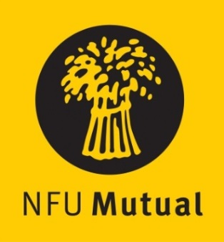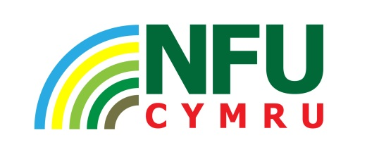

Welsh Livestock Champion
of the Year Award 2021

Win £500 and a Welsh Royal Crystal Trophy

NFU Cymru, with sponsorship from NFU Mutual,
announces the launch of a competition to choose a
Welsh Livestock Champion of the Year

This award aims to find the best livestock manager working within the agricultural industry in Wales. This competition rewards dedication and commitment and recognises the role a good stockperson can make to the Welsh livestock industry.

Criteria includes:
- How nominee started in the industry and how his/her role has grown, including details of the livestock managed

- Their role in the care and management of livestock

- How they intend developing the business

- Nominee’s vision for the future of the industry

- How nominee incorporates health and safety in their day to day activities

Nominations are invited throughout Wales. Livestock farmers are invited to nominate themselves or can be nominated by a friend, relative or organisation.

Closing date for entries is Friday 29th October 2021

The award winner will be announced at the Royal Welsh Winter Fair in Llanelwedd on Monday 29th November 2021.

The completed entry from should be returned either by email to clare.williams@nfu.org.uk or by post marked ‘Livestock Champion Award’ no later than 4.30pm on Friday 29th October 2021, to: NFU Cymru, Agriculture House, Royal Welsh Showground, Builth Wells, LD2 3TU.

