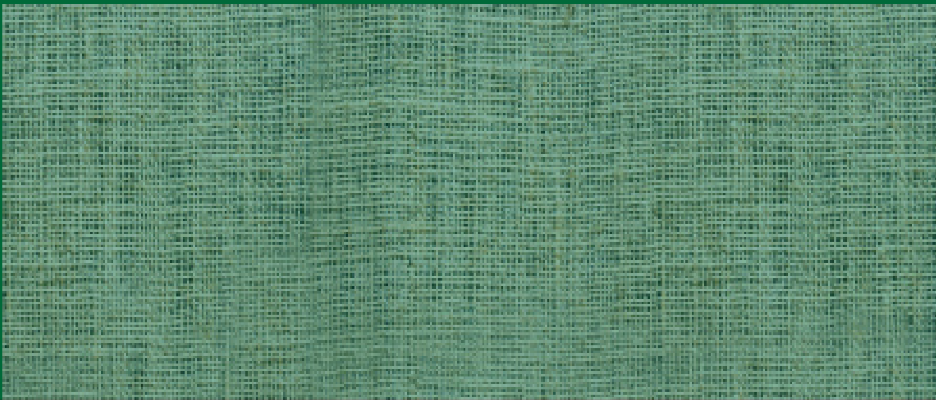
WALES WOMAN FARMER OF THE YEAR
WIN £500
Could you be the recipient of the prestigious
NFU Cymru/NFU Mutual Wales Woman Farmer of the Year Award?

The competition aims to promote the vital role of women in farming

Criteria includes:

- The part played to make the farm enterprise successful
- Any contribution made to champion the industry and, in particular, the role of women in farming
- Involvement in local community life and in other organisations.

Nominations are invited throughout Wales. Female farmers are invited to nominate themselves or can be nominated by a friend, relative or organisation.

The closing date for entries is Monday 29th May and the winner will be announced at this year’s Royal Welsh Show on Thursday 27th July.

The completed entry form should be returned either by email to: clare.williams@nfu.org.uk or by post marked ‘NFU Cymru/NFU Mutual Wales Woman Farmer of the Year competition’ no later than 5pm on Monday 29th May 2023 to: NFU Cymru, Agriculture House, Royal Welsh Showground, Llanelwedd, Powys, LD2 3TU.

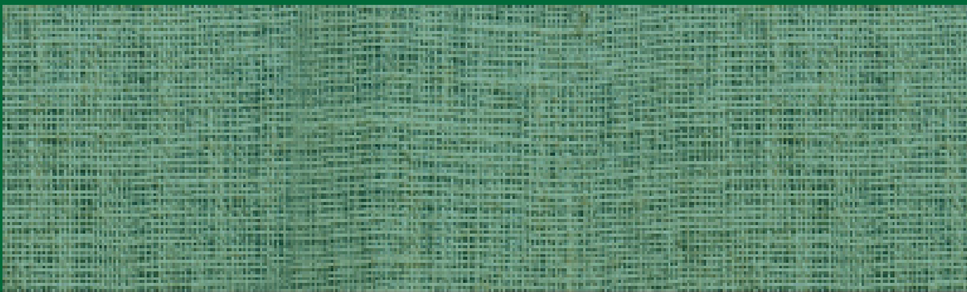
Name:

WALES WOMAN FARMER OF THE YEAR
ENTRY FORM
Address:

Contact Number:
Where did you hear about this award?

(Please state in the appropriate sections why the nominee should be considered)

- The part played to make the farm enterprise a successful economic unit

- Any contribution made to champion the industry and, in particular, the role of women in farming

- Involvement in local community life and in other organisations

[please use a separate sheet if necessary]
___________________________________________________________________________ Name and address of person submitting the nomination if different from name above:

