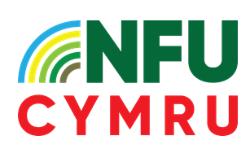
Sustainable Farming Scheme File
Farm Name
Trading Name
CRN
Scheme Year
UA | Universal Action | Applicable? | Complete? | Declared on RPW?
UA1 | Soil Health
UA2 | Integrated Pest Management (IPM)
UA3 | Benchmarking
UA4 | Continuous Professional Development (CPD)
UA5 | Habitat Maintenance
UA6 | Temporary Habitat Creation on improved land
UA7 | Designated Site Management Plans (DSMP)
UA8 | Hedgerow Management
UA9 | Woodland Maintenance
UA10 | Tree & Hedgerow Planting Opportunity Plan
UA11 | Historic Environment
UA12 | Animal Health & Welfare  - AHIC with vet  - Biosecurity Plans for incoming animals  - Body conditioning / Mobility CPD  - Body Conditioning / Lameness Record Sheets

