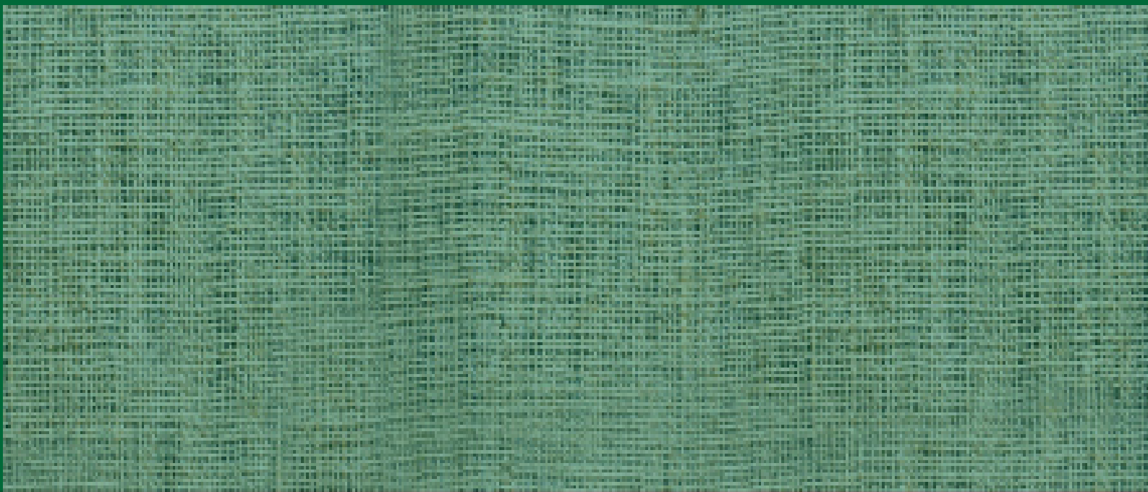



WALES WOMAN FARMER OF THE YEAR
WIN £500
Could you be the recipient of the prestigious
NFU Cymru/NFU Mutual Wales Woman Farmer of the Year Award?

The competition aims to promote the vital role of women in farming

Criteria includes:

- The part played to make the farm enterprise successful
- Any contribution made to champion the industry and, in particular, the role of women in farming
- Involvement in local community life and in other organisations.

Nominations are invited from throughout Wales. Female farmers are invited to nominate themselves or can be nominated by a friend, relative or organisation.
The closing date for entries is Friday 30th May and the winner will be announced at this year’s Royal Welsh Show on Thursday 24th July.

The completed entry form should be returned either by email to nfu.cymru@nfu.org.uk or by post marked ‘NFU Cymru/NFU Mutual Wales Woman Farmer of the Year competition’ no later than 5pm on Friday 30th May to NFU Cymru, Agriculture House, Royal Welsh Showground, Llanelwedd, Powys, LD2 3TU.

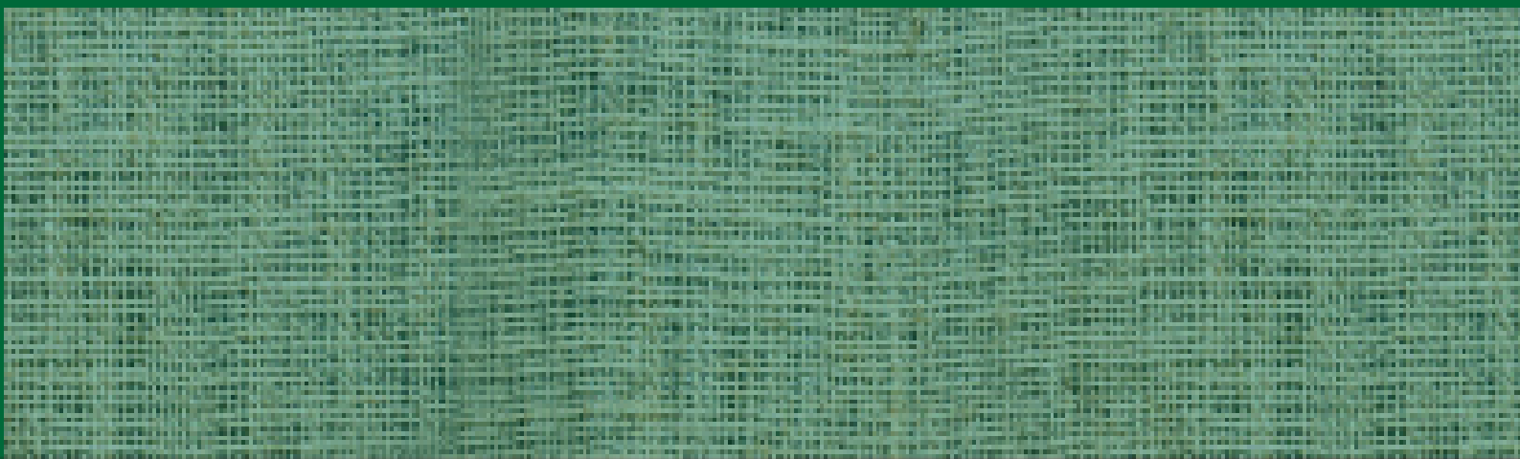
Name:

WALES WOMAN FARMER OF THE YEAR
ENTRY FORM
Address:

Contact Number:
Where did you hear about this award?

(Please state in the appropriate sections why the nominee should be considered)
- The part played to make the farm enterprise a successful economic unit

- Any contribution made to champion the industry and, in particular, the role of women in farming

- Involvement in local community life and in other organisations

[please use a separate sheet if necessary]
__________________________________________________________________________
Name and address of person submitting the nomination if different from name above:

If you’re nominating someone, is the person aware they are being nominated?
Yes / No

By completing this form you are agreeing to have this information sent to NFU Cymru for the purposes of contacting you and the nominee (if different) about this award. Read our Privacy Notice to find out about how we respect your data.

