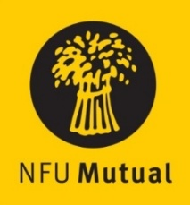

Welsh Dairy Stockperson of the Year Award

ENTRY FORM

Name:
Address:

Tel No.
(Please state in the appropriate sections why the nominee should be considered)
- Details of the dairy stock nominee manages

- How nominee started in the industry and how his/her role has grown

- Nominee’s role in the care and management of dairy stock

[please use a separate sheet if necessary to add any other relevant information]
__________________________________________________________________________________________
Name and address of person submitting the nomination if different from name above:

Please return the completed entry form either by email to sarah.phillips@nfu.org.uk or by post marked ‘Dairy Stockperson Award’ no later than 5pm on Friday 26th September 2025, to: NFU Cymru, Agriculture House, Royal Welsh Showground, Builth Wells, LD2 3TU.
By completing this form you are agreeing to have this information sent to NFU Cymru for the purposes of contacting you and the nominee (if different) about this award. Read our Privacy Notice to find out about how we respect your data.

